# Exercises in class

## Barbie’s Twitter

<https://github.com/dgrigorov/SoftUni>

Create a web page like the image below (**100% accuracy is preferable**) and make its HTML Semantic. **Use some kind of approach to support old (non-HTML5-compatible) Web browsers like IE6-IE8.**

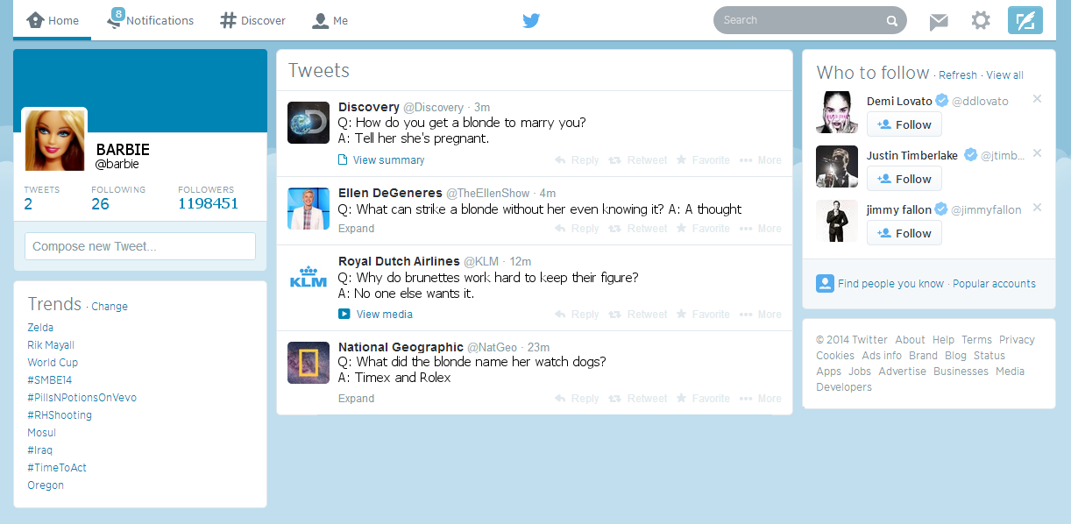

## BGJUG WebPage

Create two HTML pages like the image below (100% accuracy is not required). **Use frames for the layout of the first one. Use semantic tags and CSS for the layout of the second one.**

